- We think the Chancellor may struggle to keep the promise she made this week to avoid any more tax rises for UK businesses. Coming on top of earlier manifesto commitments, the options for increasing tax are now very limited and there are plenty of ways Reeves' wafer-thin fiscal headroom could disappear. We expect fiscal sustainability concerns to linger throughout 2025.
- New migration data suggest that net inflows have been much higher than previously thought. This backs the idea that the Labour Force Survey is grossly understating the level of employment. But it also means that growth in GDP per capita has been even more dire than we thought.
A month on from the Budget, the policy changes announced by Chancellor Rachel Reeves continue to dominate political debate in the UK. After last week's protests by farmers, Reeves attended the CBI's annual conference this week to defend her decision to increase employers' national insurance contributions.
Reeves made plain there's no prospect of the tax hike being reversed. But she also pledged there would be no more tax rises on business this parliament, saying that the budget for public services had been set for the duration of the parliament. Increasing income tax, employees' NICs, and VAT were already ruled out by Labour's election manifesto, so the options for increasing tax are now very limited. Notwithstanding the recent retreat in gilt yields, there are still plenty of ways that the Chancellor's wafer-thin headroom against the fiscal rules could disappear. So as we argued in our recent look at the key themes for 2025, fiscal sustainability concerns are likely to linger, particularly given the UK's poor debt dynamics. Rumours that the spending review will be delayed until June increase the likelihood that this issue will continue to dominate.
A policy change that pre-dates the Budget is the March 2025 end to the temporary reduction in stamp duty thresholds. Mirroring the experience of 2021, mortgage demand appears to be hotting up as buyers try to give themselves the best chance of beating the deadline, after which transaction costs will increase. Approvals for house purchases reached 68,303 in October, more than 3% up on September and the highest level since August 2022 (Chart 1).
Chart 1: Mortgage demand is hotting up ahead of March's cuts to stamp duty thresholds
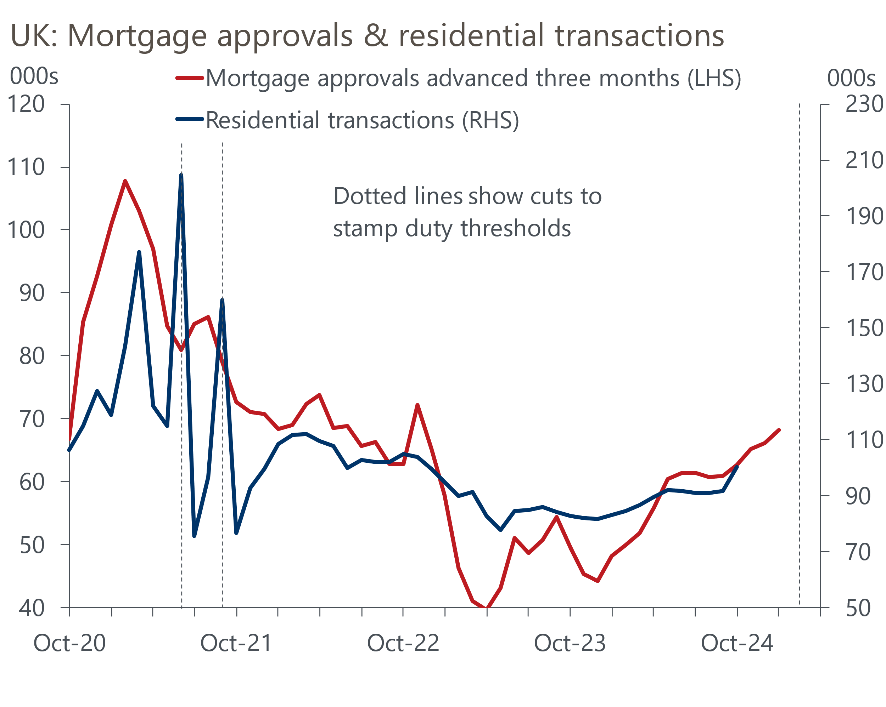
Source: Haver Analytics

The relationship between mortgage approvals and quoted interest rates has been very close of late. The recent increase in swap rates is yet to fully pass through to mortgage rates, and once lenders have adjusted their interest rates this could dampen demand a little. But we expect the boost from the upcoming stamp duty deadline to dominate in the next few months, pushing approvals higher.
This week's soundings from Monetary Policy Committee members backed our view that Bank Rate cuts are likely to continue at a gradual pace. Clare Lombardelli and Swati Dhingra both appeared at the Bank of England Watchers Conference. Dhingra was characteristically dovish, arguing that the UK no longer looked like an inflation outlier among the advanced economies. In her maiden speech, Lombardelli argued that while the risks to inflation are broadly balanced, the potential consequences of the upside risks are more serious. In a subsequent interview with the Financial Times, she expressed concerns about the stickiness of services inflation and the tightness of the labour market.
It seems unlikely that Lombardelli will consider voting for back-to-back rate cuts any time soon, a view that seems to be shared by most of the committee. Market pricing implies the probability of a December rate cut is about 5% – that feels about right to us.
Separately, the Office for National Statistics published its latest migration estimates. The previous vintage of the data had shown net inward migration peaking at a record 764,000 in the year ending December 2022, half a million higher than the average of the previous decade, then edging down a little. But the new data shows that net immigration continued to rise, reaching a new peak of 906,000 in the year to June 2023. Though inflows have subsequently fallen a little and outflows have increased, net inward migration of 728,000 in the year to June 2024 was still very high compared with historical norms (Chart 2).
Chart 2: Net inward migration has been much higher than previously estimated
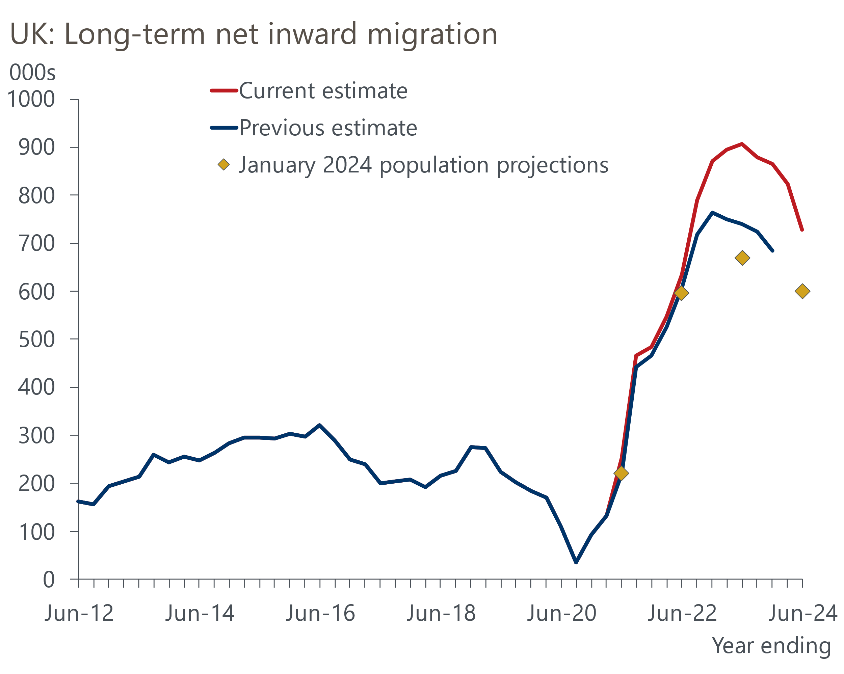
Source: ONS
It's likely that net inflows will continue to fall. The previous government implemented measures to cut legal immigration, including limiting the ability of foreign students to bring dependents to the UK, raising the minimum salary for a skilled worker visa, and increasing the minimum income required to qualify for a spousal visa. Home Office data reports large falls in the number of people granted visas to work and study in the year to September, albeit the figures remain well above pre-pandemic norms.
But the new migration data suggests that from mid-2021 onwards, net inflows have been 435,000 higher than was assumed in the most recent population projections, which were published in January. This adds to the challenges in interpreting labour market data. Higher inflows are consistent with findings of recent research by the Resolution Foundation that suggest the Labour Force Survey has been dramatically understating the level of employment and overstating the rise in inactivity. Giving evidence to the House of Lords Economic Affairs Committee this week, Huw Pill said that the BoE were coming to a similar conclusion. But while the idea the UK may not have a serious inactivity problem after all is encouraging, a higher population means growth in GDP per capita has been even more dire than we thought.

The week ahead
There's a quiet week in prospect, with only the final S&P Global surveys and house price data for November due to be published.
November's flash S&P Global survey reported that the composite PMI had dropped into contractionary territory for the first time in 12 months, following further falls in the services PMI and manufacturing output balances. As ever with the business surveys, it's difficult to separate genuine trends in activity from swings in sentiment. And with November's survey being the first since the announcement that employers' national insurance contributions will increase from April, the results were particularly prone to being affected by sentiment. With this in mind, we think there's a good chance that the construction PMI dropped sharply in November, like its manufacturing and services counterparts.
Table 1: Week ahead calendar
Date | Events | Period | Measure | Unit | Previous | Forecast
Dec 2 | Nationwide house prices | Nov | m/m | % | 0.1 | 0.2
Dec 2 | Nationwide house prices | Nov | y/y | % | 2.4 | 2.4
Dec 2 | S&P Global manufacturing | Nov | PMI | % bal | 48.6 | 48.6
Dec 4 | S&P Global services | Nov | PMI | % bal | 50.0 | 50.0
Dec 4 | S&P Global composite | Nov | PMI | % bal | 49.9 | 49.9
Dec 5 | S&P Global construction | Nov | PMI | % bal | 54.3 | 53.0
Dec 6 | Halifax house prices | Nov | m/m | % | 0.2 | 0.2
Dec 6 | Halifax house prices | Nov | y/y | % | 3.9 | 3.7
Source: Oxford Economics

Key forecasts
Table 2: UK forecast overview
(Annual percentage changes unless specified)
 | 2022 | 2023 | 2024 | 2025 | 2026 | 2027
GDP | 4.8 | 0.3 | 0.9 | 1.4 | 1.7 | 1.8
Private consumption | 7.3 | 0.5 | 0.8 | 1.7 | 1.5 | 1.6
Fixed investment | 5.1 | -0.1 | 1.0 | 0.8 | 3.4 | 2.5
Government consumption | 0.6 | 0.6 | 2.4 | 2.9 | 1.6 | 1.6
Exports of goods and services | 12.6 | -2.2 | -1.9 | 1.9 | 1.6 | 1.5
Imports of goods and services | 13.0 | -3.4 | 2.5 | 2.2 | 1.8 | 1.5
Industrial Production | -6.4 | -1.2 | -1.1 | 0.6 | 1.2 | 1.1
Consumer prices | 9.1 | 7.3 | 2.6 | 2.8 | 2.3 | 2.2
Unemployment rate (%) | 3.9 | 4.0 | 4.3 | 4.4 | 4.3 | 4.2
Current a/c balance (% of GDP) | -2.2 | -2.0 | -3.1 | -2.8 | -2.8 | -2.7
Government balance (% of GDP) | 4.1 | 5.0 | 4.5 | 3.7 | 2.9 | 2.2
Central bank policy rate (%, EOP) | 3.50 | 5.25 | 4.75 | 3.75 | 3.00 | 2.50
10yr govt. bond yield (%, EOP) | 3.67 | 3.54 | 4.50 | 4.25 | 3.85 | 3.42
Exchange rate (US$ per £, EOP) | 1.20 | 1.27 | 1.26 | 1.27 | 1.27 | 1.28
Exchange rate (euro per £, EOP) | 1.13 | 1.15 | 1.20 | 1.20 | 1.20 | 1.20
Source: Oxford Economics
Table 3: Quarterly forecasts for the UK
 | 2024 |  |  |  | 2025
 | Q1 | Q2 | Q3 | Q4 | Q1 | Q2 | Q3 | Q4
GDP (% year) | 0.3 | 0.7 | 1.0 | 1.7 | 1.4 | 1.3 | 1.5 | 1.5
CPI inflation (% year) | 3.5 | 2.1 | 2.1 | 2.6 | 2.7 | 2.7 | 3.1 | 2.7
Bank Rate (%, EOP) | 5.25 | 5.25 | 5.00 | 4.75 | 4.50 | 4.25 | 4.00 | 3.75
10yr gilt yield (%, EOP) | 3.95 | 4.17 | 4.00 | 4.50 | 4.41 | 4.38 | 4.32 | 4.25
US$ per £ (EOP) | 1.26 | 1.26 | 1.34 | 1.26 | 1.26 | 1.26 | 1.27 | 1.27
Euro per £ (EOP) | 1.17 | 1.18 | 1.20 | 1.20 | 1.20 | 1.20 | 1.20 | 1.20
Source: Oxford Economics

Latest Country Economic Forecast:
November 19, 2024

Recent publications

Data Insights
Mortgage approvals reached a 26-month high in October
November's PMI won't set alarm bells ringing yet
Retail sales fell in October, but underlying picture remains decent
October public finances shows no progress on borrowing
Inflation rose in October due to a higher energy price cap

Research Briefings
Key themes 2025 – Worrying debt dynamics shift into focus
Why the energy shock persisted for firms, but may soon fade
Macro impact of Trump’s tariffs shouldn’t be overstated
MPC sticks to the cut-hold tempo
Markets have soured on the Budget, but calm should return

Contacts

Oxford Economics' UK team
- Andrew Goodwin - Chief UK Economist - agoodwin@oxfordeconomics.com
- Edward Allenby - UK Economist - eallenby@oxfordeconomics.com

